**LAB 07**

**ENCRYPT:**

(function(){

var ConvertBase = function (num) {

return {

from : function (baseFrom) {

return {

to : function (baseTo) {

return parseInt(num, baseFrom).toString(baseTo);

}

};

}

};

};

ConvertBase.bin2dec = function (num) {

return ConvertBase(num).from(2).to(10);

};

// decimal to binary

ConvertBase.dec2bin = function (num) {

return ConvertBase(num).from(10).to(2);

};

this.ConvertBase = ConvertBase;

})(this);

encrypt('attack','qwerty')

function encrypt(pt,key){

for(let i=0;i<pt.length;i++){

console.log(String.fromCharCode(ConvertBase.bin2dec(ConvertBase.dec2bin(pt.charCodeAt(i) ^ key.charCodeAt(i)))))

}

}

**OUTPUT:**

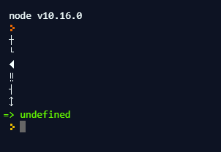

**DECRYPT:**

(function(){

var ConvertBase = function (num) {

return {

from : function (baseFrom) {

return {

to : function (baseTo) {

return parseInt(num, baseFrom).toString(baseTo);

}

};

}

};

};

ConvertBase.bin2dec = function (num) {

return ConvertBase(num).from(2).to(10);

};

// decimal to binary

ConvertBase.dec2bin = function (num) {

return ConvertBase(num).from(10).to(2);

};

this.ConvertBase = ConvertBase;

})(this);

decrypt('a','q')

function decrypt(ct,key){

for(let i=0;i<ct.length;i++){

console.log(String.fromCharCode(ConvertBase.dec2bin(ConvertBase.dec2bin(ct.charCodeAt(i) ^ key.charCodeAt(i)))))

}

}

**OUTPUT:**

